* Difference between define and const in PHP?

Const

لا يمكن ان تستخدم داخل شرط معين، بل يجب ان تستخدم في أعلى

if (...) {

const FOO = 'BAR’; // غير ممكن

}

if (...) {

define ('FOO', 'BAR'); // ممكن.

}

* const defines constants at compile time,
* define defines them at run time

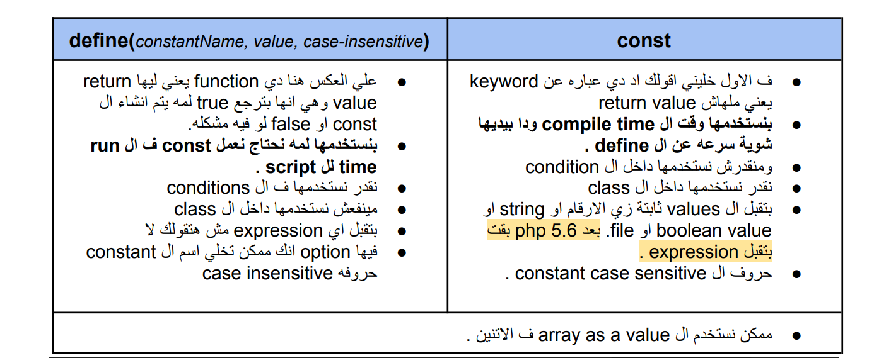

* Data Types classification in php?
* String
* Integer
* Float (floating point numbers - also called double)
* Boolean
* Array
* Object
* NULL
* Resource
* array functions (10 examples ) ?
* [count ()](https://www.w3schools.com/php/func_array_count.asp)

Returns the number of elements in an array

* [size of ()](https://www.w3schools.com/php/func_array_sizeof.asp)

Alias of [count()](https://www.w3schools.com/php/func_array_count.asp)

* [array push ()](https://www.w3schools.com/php/func_array_push.asp)

Inserts one or more elements to the end of an array

* [array replace ()](https://www.w3schools.com/php/func_array_replace.asp)

Replaces the values of the first array with the values from following arrays

* [array merge ()](https://www.w3schools.com/php/func_array_merge.asp)

Merges one or more arrays into one array